PROJECT 43
AI Form Analyzer
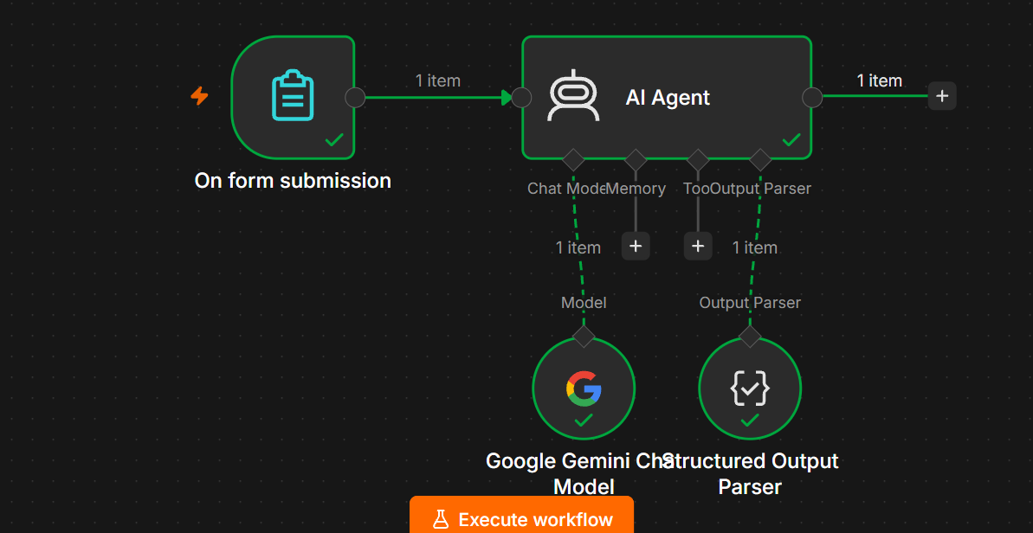
1. Project Overview
The AI Form Analyzer is an AI automation built in n8n that collects information from a form and uses Google Gemini to analyze the submitted data.
The AI can:
- Analyze form responses
- Identify important information
- Summarize the submission
- Detect missing information
- Identify key points
- Classify the response
- Provide recommendations
- Return structured JSON output

2. Objective
The objective is to create a workflow where:
Employee/User
↓
Fill Form
↓
n8n Form Trigger
↓
AI Agent
↓
Google Gemini
↓
Structured Output
Instead of manually reviewing every form response, the AI automatically analyzes it.

3. Example Use Case
Suppose you create a Customer Feedback Form.
The user submits:
Name: John
Product: Laptop
Rating: 3
Feedback:
The laptop works well but the battery backup is poor
and customer support took a long time to respond.
The AI can produce:
{
"name": "John",
"rating": 3,
"sentiment": "Negative",
"summary": "The customer is satisfied with the laptop's functionality but is unhappy with battery performance and customer support.",
"key_issues": [
"Poor battery backup",
"Slow customer support"
],
"priority": "Medium",
"recommendation": "Improve battery performance and reduce customer support response time."
}

4. Technologies Used
Technology | Purpose
n8n | Workflow automation
On Form Submission | Collect form data
AI Agent | Analyze responses
Google Gemini Chat Model | AI analysis
Structured Output Parser | Consistent JSON output

5. Workflow Architecture
Your basic workflow should be:
┌────────────────────────┐
│ On Form Submission │
│ │
│ Name │
│ Email │
│ Rating │
│ Feedback │
└───────────┬────────────┘
│
▼
┌────────────────────────┐
│ AI Agent │
│ │
│ Analyze Form Response │
└───────────┬────────────┘
│
▼
┌────────────────────────┐
│ Structured Output │
│ Parser │
└────────────────────────┘

AI Agent
│
└── Chat Model
↓
Google Gemini

6. Node 1 — On Form Submission
Add:
On Form Submission
This is the starting node.
Recommended Form Fields
For a general AI Form Analyzer, create:
Field 1
Name
Type:
Text

Field 2
Email
Type:
Email

Field 3
Subject
Type:
Text

Field 4
Rating
Type:
Number

Field 5
Response
Type:
Text Area
Use Text Area because the user may provide a detailed response.

7. Example Form
Your form can look like:
Name:
John

Email:
john@example.com

Subject:
Laptop Feedback

Rating:
3

Response:
The laptop works well but the battery backup is poor
and customer support took a long time to respond.

8. Node 2 — AI Agent
Connect:
On Form Submission
↓
AI Agent
The AI Agent will receive the form information.

9. AI Agent Prompt
In Prompt (User Message) select:
Define below
Use:
Analyze the following form submission.

Name:
{{ $json['Name'] }}

Email:
{{ $json['Email'] }}

Subject:
{{ $json['Subject'] }}

Rating:
{{ $json['Rating'] }}

Response:
{{ $json['Response'] }}

Analyze the response and provide:

1. A short summary
2. Sentiment
3. Key points
4. Issues identified
5. Priority
6. Recommendation

10. System Message
Use:
You are an AI Form Analyzer.

Your job is to analyze submitted form responses accurately and return useful insights.

IMPORTANT RULES:

1. Analyze only the information provided in the form.
2. Do not invent information.
3. Create a concise summary.
4. Identify the overall sentiment.
5. Extract important key points.
6. Identify problems or issues mentioned by the user.
7. Assign a priority based on the seriousness of the issues.
8. Provide a practical recommendation.
9. Preserve the submitted information accurately.
10. Use professional and clear language.
11. Return the result using the required structured output format.

11. Node 3 — Google Gemini Chat Model
Add:
Google Gemini Chat Model
Connect it to the AI Agent's:
Chat Model
Connection:
Google Gemini Chat Model
↓
AI Agent
Do not connect it using the normal workflow line.

12. Node 4 — Structured Output Parser
Add:
Structured Output Parser
Connect it to the AI Agent's:
Output Parser
The connection should be:
AI Agent
│
└── Output Parser
↓
Structured Output Parser

13. Structured Output
Enable:
Require Specific Output Format
Then configure the Structured Output Parser using this JSON example:
{
"name": "John",
"email": "john@example.com",
"subject": "Laptop Feedback",
"rating": 3,
"sentiment": "Negative",
"summary": "The customer is satisfied with the laptop's functionality but is unhappy with battery performance and customer support.",
"key_points": [
"Laptop functionality is good",
"Battery backup is poor",
"Customer support response was slow"
],
"issues": [
"Poor battery backup",
"Slow customer support"
],
"priority": "Medium",
"recommendation": "Improve battery performance and reduce customer support response time."
}

14. Final Workflow
Your n8n canvas should look like:
┌───────────────────────┐
│ On Form Submission │
└───────────┬───────────┘
│
▼
┌───────────────────────┐
│ AI Agent │
└───────────┬───────────┘
│
└──── Output Parser
↓
Structured Output
And:
Google Gemini Chat Model
│
↓
AI Agent

15. Test Data
Use this first:
Name
John
Email
john@example.com
Subject
Laptop Feedback
Rating
3
Response
The laptop works well but the battery backup is poor
and customer support took a long time to respond.

16. Expected Output
You should receive something similar to:
{
"name": "John",
"email": "john@example.com",
"subject": "Laptop Feedback",
"rating": 3,
"sentiment": "Negative",
"summary": "The customer is satisfied with the laptop's functionality but is unhappy with battery performance and customer support.",
"key_points": [
"Laptop functionality is good",
"Battery backup is poor",
"Customer support response was slow"
],
"issues": [
"Poor battery backup",
"Slow customer support"
],
"priority": "Medium",
"recommendation": "Improve battery performance and reduce customer support response time."
}

17. Sentiment Rules
The AI can classify the response as:
Positive
Neutral
Negative
Mixed
Positive
Example:
The product is excellent and the support team was very helpful.
Output:
Positive
Negative
Example:
The product stopped working and support did not respond.
Output:
Negative
Mixed
Example:
The product quality is excellent, but delivery was very late.
Output:
Mixed

18. Priority Rules
Use:
Low
Medium
High
Low
Minor feedback with no urgent problem.
Medium
A significant issue that should be reviewed.
High
Serious complaint, urgent issue, major service failure, or critical problem.

19. Second Test
Try:
Name:
Sarah

Email:
sarah@example.com

Subject:
Service Feedback

Rating:
5

Response:
The service was excellent. The team was very helpful
and responded quickly to all my questions.
Expected:
{
"sentiment": "Positive",
"priority": "Low"
}

20. Third Test
Try:
Name:
Mike

Email:
mike@example.com

Subject:
Delivery Complaint

Rating:
1

Response:
My order arrived two weeks late and the product was
damaged. I contacted support three times but nobody
helped me.
Expected:
{
"sentiment": "Negative",
"priority": "High"
}

21. What This Project Demonstrates
This project demonstrates several important AI Agent concepts:
- Form automation
- Dynamic n8n expressions
- AI Agent
- Prompt engineering
- Google Gemini integration
- Structured output
- Sentiment analysis
- Text summarization
- Issue extraction
- AI-based prioritization

22. Optional Enhancements
After the basic workflow works, you can add:
Google Sheets
Form
↓
AI Agent
↓
Google Sheets
Store every analyzed response.
Email
AI Agent
↓
IF Priority = High
↓
Gmail
↓
Notify Manager
Slack
AI Agent
↓
IF Priority = High
↓
Slack
↓
Alert Support Team
Dashboard
Store the results and create a dashboard showing:
- Total submissions
- Positive responses
- Negative responses
- Average rating
- High-priority issues
- Most common complaints

23. Final Project Summary
Project: AI Form Analyzer
Input:
Form submission
Processing:
AI Agent + Google Gemini
Output:
Summary
Sentiment
Key Points
Issues
Priority
Recommendation
Final architecture:
On Form Submission
↓
AI Agent
↙ ↘
Gemini Output Parser
↓
Structured JSON
Important: For this basic AI Form Analyzer, you do not need a Vector Store, Data Loader, Text Splitter, or embeddings. Those are useful for RAG/knowledge-base projects like your AI HR Assistant, but they are unnecessary here.

